MESS MITRA

Purpose: The Mess Mitra app is proposed to manage mess complaints raised by students from respective campuses.
The app users are students, mess representatives, mess committee members, and possibly administrators from respective campuses.
Core Features:
- Role-Based Access: Students can access abilities:
          - Raising a complaint.
          - Can know which authority is handling his complaint.
          - Can see overall reports.
          - Can support other students' problems that have been raised.
          - He can escalate his complaint when the given solution is not satisfactory.
          - Can give mess feedback through the app.
Mess Representatives accessed abilities:
        - Mess Representatives (MRs) can access all students' abilities.
        - Can handle small complaints/issues that are solved easily.
        - Can merge repeated complaints to reduce repetition of complaints.
        - Can access the mess coordinator’s information for communication purposes.
Mess Coordinators accessed abilities:
            - Capable of handling complaints
            - Able to view overall reports
            - Can access MR’s information

Higher Authorities (Mess Committee) accessed abilities:
- Capable of handling unsolved complaints
- Able to view overall statistics
2. Complaint tracking status:
The complaint tracking status is given to the student who raised the complaint.
- when a complaint is created the status of the complaint is Created.
- Then the complaint is taken by any authorized person (a person who can opt and solve complaints), and now the complaint status is changed to In progress.
- To close the complaint, the authorized person must provide a resolution, such as marking it as "Solved" or "Unsolved." The complaint is then temporarily closed, and its status is updated accordingly.
- If the proposed solution is not satisfactory, a student can raise the complaint again by mentioning why he/she wants to raise the complaint again. re-raised the complaint, the status was changed to Re-raised.
3. Category-wise and DH (Dining Hall) wise complaint segregation:
The complaints raised by students are displayed category-wise to the students and DH-wise to the mess coordinators and mess committee in the all complaints section.
4. Ability to Reopen or re raise the complaint:
Students can reopen or re-raise the complaint if the provided solution is not satisfactory. To reopen or re-raise the complaint, the student have to give why he wants to re-raise the complaint and press the YES button for confirmation. In this process, If the complaint is closed by MR (Mess Representative), the complaint is forwarded to Mess coordinator. If the complaint is closed by Mess coordinator, the complaint is forwarded to Mess committee members.
5. Reports page:
We added a reports page, where the users can get the count of no. of complaints: Raised/created, In progress, Solved, Unsolved, and Re-raised are represented in graphical/pie chart diagrams.
In this page, we depicted for:
    - Students gets the view of all complaints status in pie chart as category wise like Neatness, Quality, Quantity, etc. each category has each pie chart representation.
    - Mess coordinator gets the view of all complaints status in pie chart from respected Dining Hall’s Data and categories from respected halls.
    - Mess Committee gets the view of complaints in each dining hall. Like 6 halls have 6 pie charts only, in that we’ll show how many are Raised, In progress, Solved, Unsolved, Re-raised?
6. My Complaints Page:
We added a my complaints page, where
      - Students can access the complaints data which are raised by them and their status.
      - Mess representative access the complaints data which they have raised, taken, and merged.
      - Mess Coordinator can access the complaints data which they taken and not closed.
      - Mess committee can access the complaints data which are re-raised with specific reason. And which are immediate solution is required.
7. Add Complaints Page:
We added a add complaints page, where the students and mess representatives can add their complaints regarding their allocated mess with the details like complaint title, complaint description, images related to complaint, selecting mess where the complaint is raised and the category of complaint are the basic details to raise a complaint.

8. All Complaints Page:
We added a all complaints page, where
      - Students can access the complaints data which are raised by all and their status. And they can support the each others complaints to increase the importance of the complaint.
      - Mess representatives can merge all the repeated complaints using an id provided in the complaints page with a reason. It avoids the duplication of complaints.

9. Info Page:
We added a info page, where the mess coordinators information is shown for the mess representatives, mess coordinators, mess committee.

Technological Approach:
- Flutter : It is the backbone of the app’s user interface, providing a responsive framework.
- Firebase Authentication : It ensures secure and user-friendly access to the app.
- Firebase Database : The app employs Firebase Database to store the data efficiently.
- Firebase Storage : It is used for managing and storing user-uploaded files, such as images or documents.
- Android Webview Implementation : The app integrates Android WebView for a smoother display of web-based content.

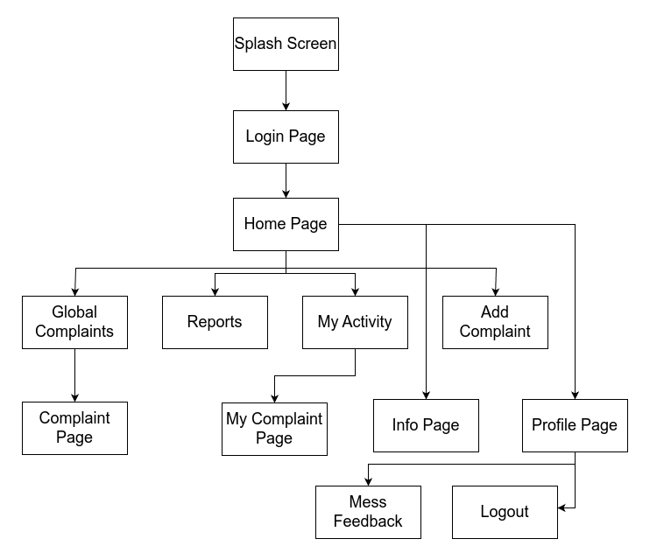
User Workflow:

